Program Structures and Algorithms

Spring 2023(SEC – 03)

NAME: Changyu Wu

NUID: 002111594

**Task: Assignment 1 – Random Walk** (Find relationship between d and m)

**Relationship Conclusion:**

1. d = -0.0005m2 + 0.128m + 1 (1 <= m <= 100)

d = -0.0002m2 + 0.047m + 1 (1 <= m <= 1,000)

1. The larger m, the larger d.
2. The growth speed of d will gradually become slower when m becomes larger. For instance, when m is in the range of [1,100], d grows fast. When m is in the range of [900, 1000], d grows slowly.

**Evidence to support that conclusion:**

1. In order to find a more precise relationship between m and d, we need to increase the number of experiments (n). In the following Graph 1, I set n to 100, which resulted in a random line chart. While in Graph 2, I set n to 10,000. Apparently, we could get more regular curves with larger n.
2. Based on the following curves, the growth of distance (d) becomes slow when m increases. I guess the equation might be logarithmic or quadratic. To verify the conjecture, I plot the result on a log/log graph (Graph 3). The slope on the plot is around 2. Therefore, I think the relationship between m and d might be quadratic.
3. From the following tables and Graph 4 and 5, we could get an approximate equation which represents the relationship between d and m (1 <= m <= 100 and 1 <= m <= 1,000). (Conclusion 1)

Table 1: 1 <= m <= 100 Table 2: 1 <= m <= 1,000

1. Based on the Graph 5, we could get Conclusion 2 and 3.

**Graphical Representation:**

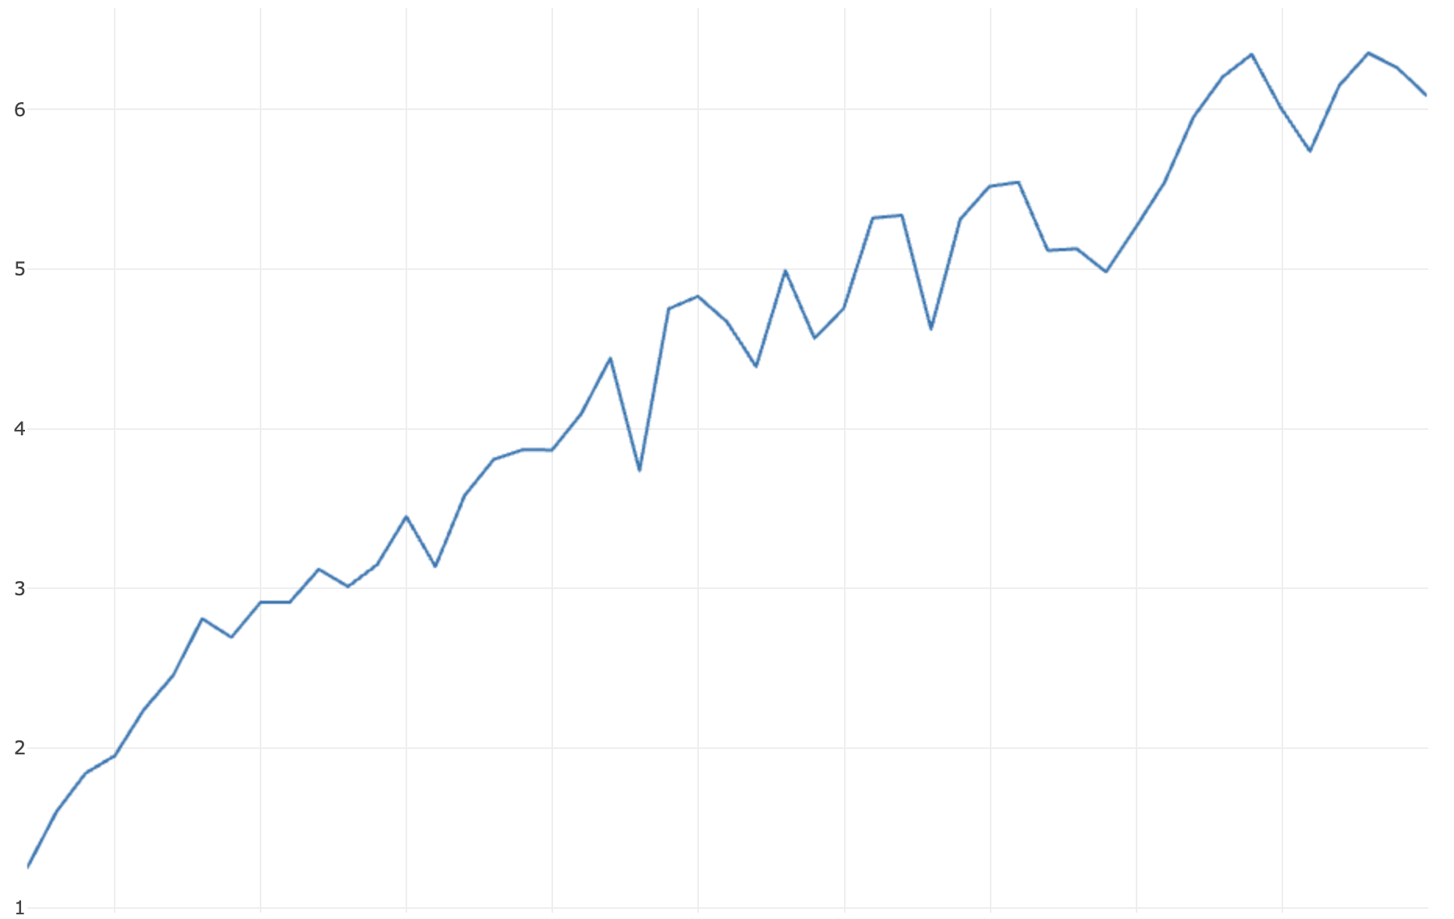

Graph 1: n = 100, x = m = [1, 50], y = d Graph 2: n = 10,000, x = m = [1, 50], y = d

Graph3: log(m)/log(d)

Graph 4: n = 10,000, x = m = [1, 100], y = d Graph 5: n = 10,000, x = m = [1, 1,000], y = d

**Unit Test Screenshots:**

